RFI RESPONSE RE 10 TANKERTON ROAD

- Provide a building material schedule outlining the materials used for the proposed building. This includes brand, material type, colour, finishes, product name and product code (if applicable).
ANSWER:
1. Main Roof Sheeting/Verandah Roof Sheeting
- Brand: BlueScope/Laserlite
- Material Type: Colorbond steel/Intermittent Colorbond & Poly Carbonate
- Product Name: Colorbond Custom Orb/Laserlite (Corrugated)
- Colour: Woodland Grey/Gun Metal (north above entry), Opal (south)
- Finish: Standard

2. Wall Sheeting (External)
- Brand: BlueScope
- Material Type: Colorbond steel
- Product Name: Colorbond Custom Orb (Corrugated)
- Colour: Woodland Grey
- Finish: Standard

3. Structural Frame
- Brand: Shed Bonanza or similar (fabricated via Australian Tube Mills)
- Material Type: Galvanised structural steel
- Product Name: C-Section & RHS Portal Frame System
- Finish: Hot-dip galvanised

4. Purlins & Girts
- Brand: Stramit or Lysaght
- Material Type: Galvanised steel
- Product Name: C-Purlin / Z-Purlin
- Finish: Galvanised

5. Sliding Windows (Commercial Grade)
- Brand: Bradnam’s or Stegbar
- Material Type: Aluminium framed
- Product Name: Commercial Sliding Window
- Colour: Black (powder-coat)
- Finish: Matt

6. Main Entry Door — Automatic Sliding
- Brand: Kone (or equivalent commercial automatic door supplier)
- Material Type: Aluminium framed automatic sliding door system
- Product Name: KONE Automatic Sliding Door – Commercial Series
- Colour: Black (powder-coat)
- Finish: Matt

7. Gutters & Downpipes
- Brand: BlueScope
- Material Type: Colorbond steel
- Product Name: Quad Gutter
- Colour: Woodland Grey
- Finish: Standard

8. Internal Lining (Restaurant/Bar & Kitchen Areas)
- Brand: CSR/James Hardie
- Material Type: Plasterboard and timber features/Cement Sheet
- Product Name: Gyprock/Villaboard
- Finish: Painted/Clad with George Archer Stainless Sheet
- Colour: White/Stainless

9. Flooring
- Brand: Local contractor / Boral concrete
- Material Type: Concrete slab
- Product Name: Polished Concrete – Commercial Finish
- Finish: Satin
- Colour: Natural

10. Insulation
- Brand: Bradford/Knauf
- Material Type: Glasswool/Earthwool
- Product Name: Bradford Hi-Performance Wall Batts/Roofing Blanket Roll
- Finish: N/A

- Provide amended site plans to show the location of on-site effluent disposal areas.

ANSWER: Please see the amended site plan including septic details as requested. I’ve also included relevant correspondence between myself, Carl Gheller (then Senior Environmental Health Officer Bass Coast Shire) and Suzy Thomas, which confirms the previous septic detail and approval.
What has changed? The previous buildings which burnt down, comprised the main double-storey building with six bedrooms upstairs and four cabins next to the main building. In total, there were 9 toilets, serviced by two septic systems (one large and one small) as shaded in blue on diagram “OLD”.
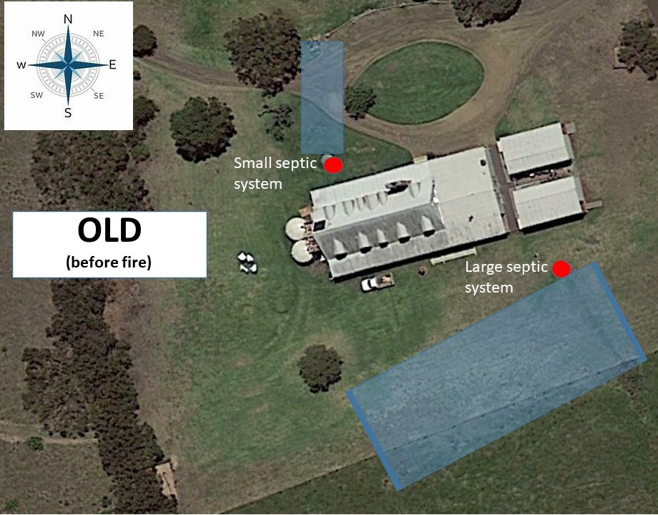
The new proposal is ground level with only 4 toilets, to comply with patron numbers and staff requirements. The largest septic system fortunately sustained no damage from the fire, so we have designed the new proposal with a floorplan to position the new toilets in close proximity to that septic system. Please see as shaded in blue on the diagram below:
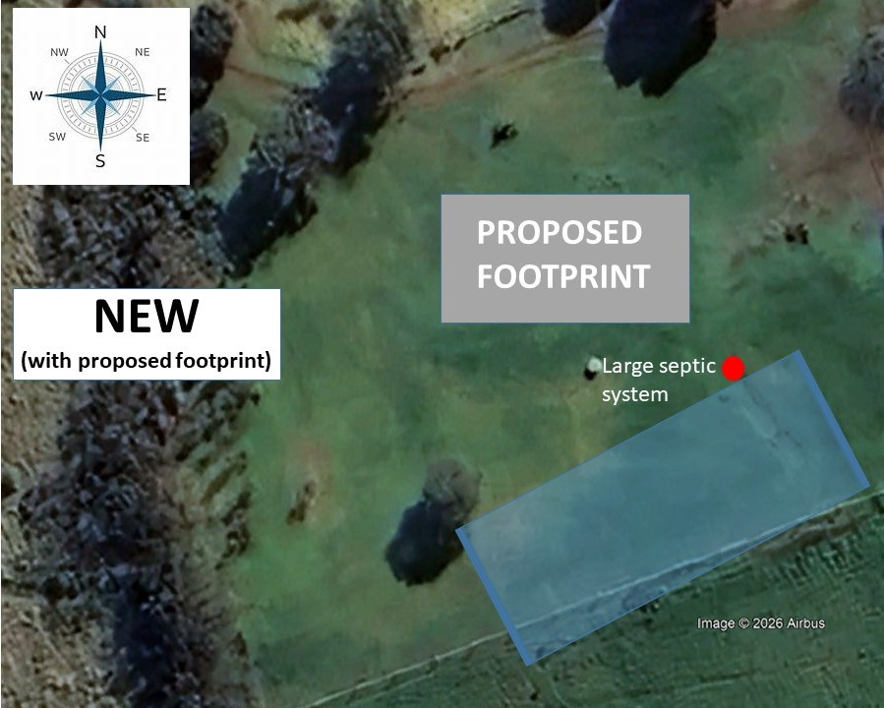

- Provide amended site and floor plans showing consistent building orientations and north point.

ANSWER: Please see below footprint now due north to maximise off-grid energy efficiency.
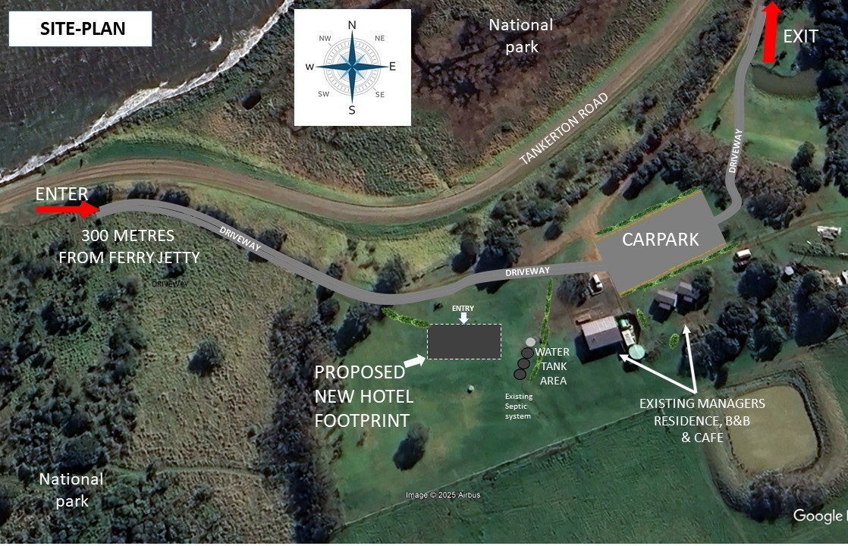

FLOOR-PLAN WITH CORRECTED NORTH POINT
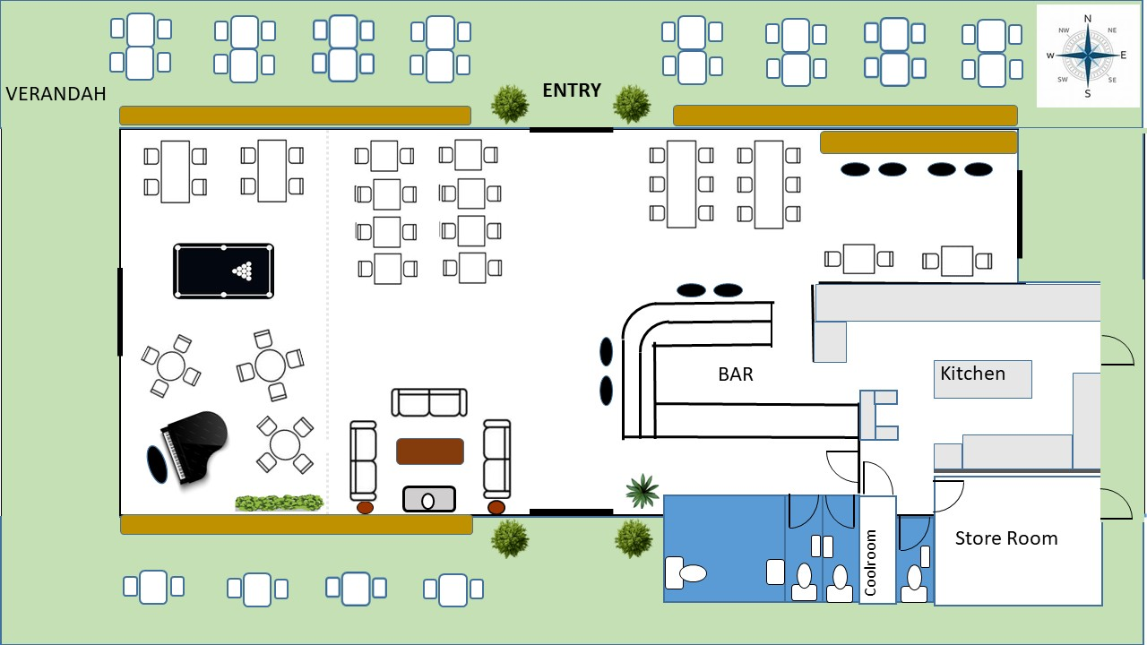

4. Provide amended elevations to clarify the net height of the building (this information is
currently partially obscured in the elevations).
ANSWER: Please see amended elevations diagram with unobscured measurements below
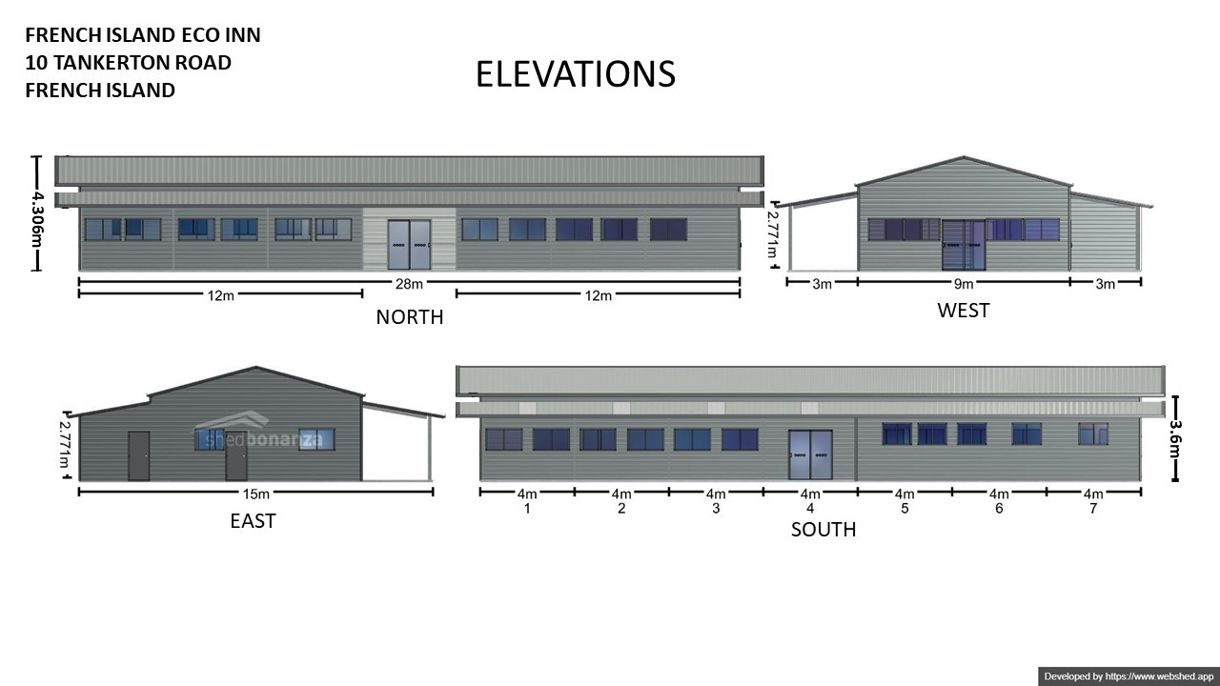

5. Please clarify whether any excavation or filling is proposed and provide information on depth.
ANSWER: The proposed building footprint has an overall fall of approximately 500 mm across the site. To establish a level construction base, the works will involve both excavation and filling. The higher portion of the site will be reduced by up to 250 mm, while the lower portion will receive up to 250 mm of engineered fill. This will create a consistent, level platform across the full footprint.

PREVIOUS CORRESPONDENCE REGARDING SEPTIC SYSTEMS

- Please note for reference; Tank A (small system) damaged in fire, Tank B (Large system) Undamaged & Retained, Tank C Managers Residence (still in use)

From: Phil Bock [mailto:innonfrench@gmail.com]
Sent: Wednesday, 16 August 2017 3:58 PM
To: Carl Gheller
Subject: Guesthouse/Hotel French Island

Hi Carl,
Hope you're well.
We've been up to our armpits in mud, trying to confirm this septic tank issue and are now satisfied that we have a fairly accurate understanding of the system.
Hopefully the information herewith can enable you to proceed further from your end, but please let me know if you require anything further.
Thanks Carl.

Regards,
Philip Bock
Ph: 5980 1234
Re: 10 TANKERTON ROAD, TANKERTON, FRENCH ISLAND

The buildings were purpose-built to trade as a guesthouse in 1982-1983.
These works including the septic systems which, according to a retired plumber familiar with the property, were installed in compliance with commercial requirements at that time. These works were apparently registered with the Mornington Shire, however it appears they have no record of this.
Upon arrival at the property 6 years ago, we had the septic tanks emptied and re-filled with fresh water.
During the last 5 years we have had spasmodic patron numbers attending the property, with no visible impact on the septic tanks, no apparent smell, no visible overflow and no need for further emptying.
Larger group numbers also attending the property during this time include:
Many groups of 20 students, staying for three nights at a time.
Two function groups, each of 120 people, using the property from 10am until 10pm.
Two larger function groups each of 150 people, using the property from noon until midnight.
These “shock-loads” have also shown no visible impact on the septic tanks, no apparent smell, no visible overflow and no need for further emptying.
Following further investigation by way of limited excavation and probing the ground to locate the septic outlet piping, it appears the septic tank details are as follows:
Tank A: Approximately 120 linear metres installed in a zig-zag configuration with approximately 110metres of agricultural pipe under the lawn areas, interfaced with approximately 10metres of stormwater pipe under the driveway section.
Tank B: Approximately 200 linear metres installed in a zig-zag configuration of agricultural pipe, all under lawn areas, including two distribution pits and a sand-filter.
Tank C: Approximately 100 linear metres installed in a zig-zag configuration of agricultural pipe, all under lawn areas, ending in a reed-bed area.

In summary, To my knowledge, during the last 34 years of trade at the property, there has not been any issue with the septic tanks. Should the need arise for additional tanks etc., the 17 acre property is large enough to support additional suitable infrastructure accordingly.

 | 16 Aug 2017, 16:41
  Carl Gheller <Carl.Gheller@basscoast.vic.gov.au>
to suzy.thomas@delwp.vic.gov.au, me

Hello Phil thank you for your email there is enough information there for me to make a determination about your application. I consider the length of trench line is adequate to service the intended activity. I will formally prepare a response to Suzi Thomas and cc: my response to both parties as I have done with this email. Thank you for your cooperation and investigation with this matter. Cheers

Carlo Gheller
senior environmental health officer

 | 17 Aug 2017, 09:37
  Carl Gheller <Carl.Gheller@basscoast.vic.gov.au>
to me

Hi Phil I received an email from Suzy Thomas this morning. She is happy with my formal response to your application. My job in relation to your application is now complete. I wish you luck with your future VCAT hearing. Cheers

Carlo Gheller
senior environmental health officer

